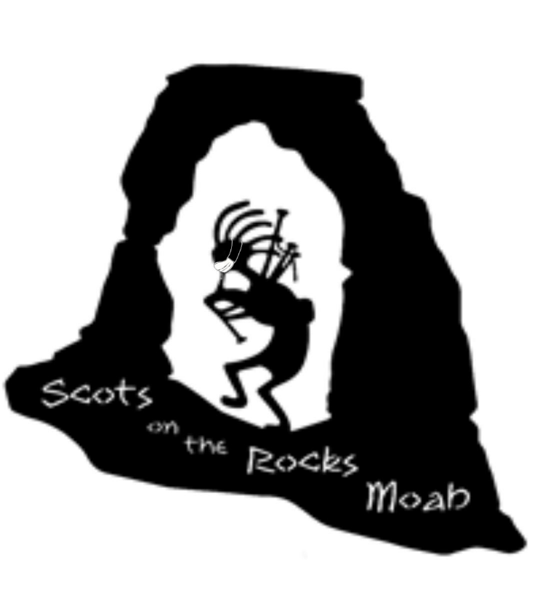
Greetings Clans! We hope you have stayed healthy during the pandemic. It’s certainly been an interesting year, to say the least.
We have some very exciting news this year! WE ARE MOVING to a new venue and moving to an early date to (hopefully!) avoid the nasty weather we’ve experienced in November.
We are writing to invite you to the 8th Annual Moab Celtic Festival brought to you by “Scots on the Rocks” to be held SEPTEMBER 17-19, 2021 at the Center Street Ball Field in beautiful downtown Moab! See attached Clan Registration.
As you know, Moab is busy every weekend, with multiple events scheduled so we suggest you reserve your lodging as early as possible. We will be posting special motel rates as soon as we can. There are several RV parks nearby.
Please be advised that we have a COVID plan in place, that we will post on the website, which is subject to change as necessary. The mask mandate might be in place in Moab longer than the rest of the state because of the influx of tourists.
When you arrive, please check in with the Clan Relations table/INFO booth at the Center Street Ball Fields at 250 E Center. You will be given your packet with more information and wrist bands. You must have your wristband on to enter the Park for the Tattoo on Friday and the Fest on Saturday and Sunday. We have provided two wristbands for you and your representative. If you need more, please let us know.
You can set up on Friday, September 17, between 8:00 am and 3:00 pm. You will be able to enter the park on the west side to unload your vehicle. Please be sure to move your vehicle off the field before 3 pm, as we will lock the gates. Please be ready by 4:00 pm when we open the gate for patrons!! We are planning to start the Tattoo at 6:00 pm on Friday and the Ceilidh at 6:00 pm on Saturday. The City of Moab has a sound ordinance in place. The festivities will end at 9:00 pm with “lights out” at 10:00 pm when we will lock the gates. We are also planning a PARADE from the Visitor’s Center to the Ball Fields on Saturday morning. Please keep an eye on our website www.scotsontherocksmoab.org and our facebook page Moab Celtic Festival for more updates
There will be security on the field during the Tattoo and overnight. Please secure your tent for the night. There will not be electricity to the Clan Tents. Please have your tent ready by 9:00 am on Saturday and Sunday and remain open until 5:00 pm.
Again, we look forward to seeing you and your clan! We want this Fest to be as awesome as it can be, so if you have any suggestions for us, please share!

Dan and Marta Lamont, Clan Relations
435-210-0080 and 435-260-2456

